Multiple Choice Questions

1) | Which of the following formulas would be a carbohydrate

A) | C₅H₁₂O₅
B) | C₄H₈O₆
C) | C₆H₁₀O₆
D) | C₃H₈O₃
E) | C₆H₁₂O₆

Answer: E

Difficulty: 1 Topic: Monosaccharides

2) | How many carbon atoms are found in the smallest molecules that are classified as carbohydrates?

A) | 1
B) | 2
C) | 3
D) | 4
E) | 5

Answer: C

Difficulty: 1 Topic: Monosaccharides

3) | Dihydroxyacetone is classified as a(n) _______.

A) | aldotriose
B) | ketotriose
C) | aldotetrose
D) | ketotetrose
E) | none of the above

Answer: B

Difficulty: 1 Topic: Monosaccharides

4) | Which stereoisomer of threose is shown below?
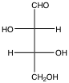
A) | D
B) | L
C) | D, L
D) | L, D
E) | none of the above

Answer:

Difficulty: 1 Topic: Monosaccharides

5) | How many stereoisomers would be expected from a ketohexose?

A) | 4
B) | 8
C) | 16
D) | 32
E) | 64

Answer: B

Difficulty: 1 Topic: Monosaccharides

6) | What is the C-4 epimer of glucose?

A) | allose
B) | mannose
C) | gulose
D) | galactose
E) | fructose

Answer: D

Difficulty: 2 Topic: Monosaccharides

7) | Which of the following would be the correct Haworth projection for α-D-gulose, whose linear form is seen below?
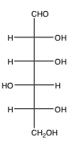
A) | 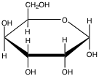
B) | 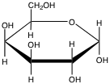
C) | 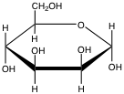
D) | 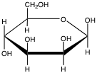
E) | None of the above

Answer: A

Difficulty: 2 Topic: Monosaccharides
8) | Which of the following is a ketose?

A) | 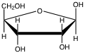
B) | 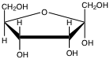
C) | 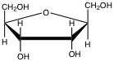
D) | 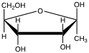
E) | None of the above

Answer: B

Difficulty: 2 Topic: Monosaccharides

9) | Which of the following is a diastereomer of D-mannose?

A) | D-gulose
B) | D-altrose
C) | D-idose
D) | D-talose
E) | all of the above

Answer: E

Difficulty: 1 Topic: Monosaccharides

10) | Which of the following would be an anomer of α-D-galactopyranose?

A) | 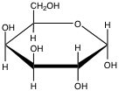
B) | 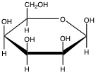
C) | 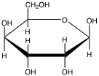
D) | 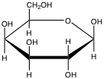
E) | None of the above

Answer: D

Difficulty: 2 Topic: Monosaccharides

11) | Gluconic acid is derived from ________ while glucuronic acid is derived from _______.

A) | glucose; gulose
B) | gulose; glucose
C) | glucose; glucose
D) | glucose; galactose
E) | galactose; glucose

Answer: C

Difficulty: 2 Topic: Derivatives of Monosaccharides

12) | Of the following phosphate esters of monosaccharides, which has the most spontaneous ΔG°´ of hydrolysis?

A) | α-D-glucose-6-phosphate
B) | β-D-glucose-6-phosphate
C) | β-D-glucose-1-phosphate
D) | α-D-fructose-6-phosphate
E) | D-glyceraldehyde-3-phosphate

Answer: C

Difficulty: 2 Topic: Derivatives of Monosaccharides

13) | The two most common amino sugars, β-D-glucosamine and β-D-galactosamine are formed from their respective carbohydrates by substitution of an amine group for the hydroxyl on carbon _____.

A) | 2
B) | 3
C) | 4
D) | 5
E) | 6

Answer: A

Difficulty: 1 Topic: Derivatives of Monosaccharides

14) | The reaction of a cyclic monosaccharide with an alcohol converts a(n) _________ into a(n) ________.

A) | acetal; hemiacetal
B) | hemiacetal; acetal
C) | acetal; ether
D) | hemiacetal; ether
E) | alcohol; ether

Answer: B

Difficulty: 2 Topic: Derivatives of Monosaccharides

15) | Which of the following designations best characterizes the following disaccharide?
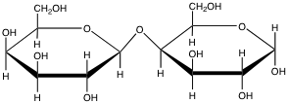
A) | Glcα(1→4)Gal
B) | Glcβ(1→4)Gal
C) | Galα(1→4)Gal
D) | Galβ(1→4)Gal
E) | none of the above

Answer: D

Difficulty: 2 Topic: Oligosaccharides

16) | Lactose, the disaccharide of galactose and glucose, is synthesized from which of the following activated monosaccharides?

A) | uridine triphosphate glucose
B) | uridine triphosphate galactose
C) | uridine diphosphate glucose
D) | uridine diphosphate galactose
E) | none of the above

Answer: D

Difficulty: 1 Topic: Oligosaccharides

17) | Which of the following explains the importance of sucrose as a disaccharide?

A) | the glycosidic bond is much more stable than a typical glycosidic bond
B) | the presence of two glucose residues provides a readily available glucose source
C) | β-glycosidic bonds are much more stable than α-glycosidic bonds
D) | since both anomeric carbons are involved in the glycosidic bond, oxidation is limited
E) | none of the above

Answer: D

Difficulty: 2 Topic: Oligosaccharides

18) | Which of the following polysaccharides contains exclusively glucose in β(1→4) glycosidic bonds?

A) | amylose
B) | amylopectin
C) | glycogen
D) | cellulose
E) | chitin

Answer: D

Difficulty: 1 Topic: Polysaccharides

19) | The role of collagen in vertebrate bones as a matrix for mineral deposition is most analogous to the role of _________ in ___________.

A) | cellulose; plant cell walls
B) | chitin; invertebrate exoskeletons
C) | xylan; plant cell walls
D) | keratan sulfate: mammalian skin
E) | amylose: plant cell walls

Answer: B

Difficulty: 2 Topic: Polysaccharides

20) | All glycosaminoglycans contain which of the following?

A) | a sulfate ester
B) | a β(1→4) glycosidic bond
C) | a carboxylate
D) | an amine group that is either acetylated or sulfated
E) | all of the above

Answer: D

Difficulty: 2 Topic: Polysaccharides

21) | Which of the following correctly identifies key elements present on the exterior of Gram-negative (GN) and Gram-positive (GP) bacteria?

A) | GN: single lipid bilayer; GP: two lipid bilayers
B) | GN: single peptidoglycan layer; GP: multiple peptidoglycan layers
C) | GN: extensively crosslinked peptidoglycans; GP: uncrosslinked peptidoglycan
D) | GN: contains both N-acetylmuramic acid and N-acetylglucosamine; GP: contains only N-acetylmuramic acid
E) | none of the above

Answer: B

Difficulty: 2 Topic: Polysaccharides

22) | An N-linked glycan would be attached to ______ while an O-linked glycan would be attached to ________.

A) | Asn; Ser
B) | Lys; Tyr
C) | Gln; Thr
D) | Arg; Ser
E) | Lys; Ser

Answer: A

Difficulty: 2 Topic: Glycoproteins

23) | Oseltamivir, also known as Tamiflu, is effective as an antiviral against the influenza virus due to its ability to block the action of which protein associated with the surface of the viral particle?

A) | hemagglutinin
B) | neuraminidase
C) | M1
D) | M2
E) | none of the above

Answer: B

Difficulty: 2 Topic: Glycoproteins

24) | The source of nitrogen for the synthesis of glucosamine-6-phosphate from fructose-6-phosphate is the amino acid ___________.

A) | aspartate
B) | asparagine
C) | glutamate
D) | glutamine
E) | lysine

Answer: D

Difficulty: 1 Topic: Biosynthesis of Glycoconjugates—Amino Sugars

25) | Antibiotic inhibition of cell wall synthesis can be facilitated by a number of agents. The crosslinking of peptidoglycan strands is inhibited by _________ while polymerization of the growing peptidoglycan is inhibited by __________.

A) | penicillin; bacitracin
B) | penicillin; vancomycin
C) | vancomycin; bacitracin
D) | vancomycin; penicillin
E) | bacitracin; vancomycin

Answer: B

Difficulty: 3 Topic: Glycoconjugates of Interest

Short Answer Questions

1) Using the structure of D-altrose, shown below, show a Haworth projection for the β anomer.

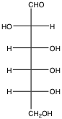

Answer:
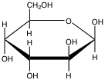

Difficulty: 2 Topic: Monosaccharides

2) Given the structure of D-galactose, draw the structure of L-galactose in both open chain and Haworth projections (α anomer).

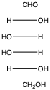

Answer:
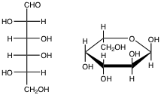

Difficulty: 3 Topic: Monosaccharides

3) Draw a β-disaccharide composed of glucose linked to its C-2 epimer by an α(1→4) glycosidic bond with the anomeric carbon of glucose contributing to the glycosidic bond.

Answer:
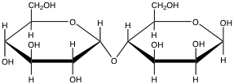

Difficulty: 2 Topic: Oligosaccharides

4) Show the interaction that would take place between the R-group of asparagine in a protein and the substituent on C-2 of an N-acetylglucosamine residue of a glycan.

Answer:
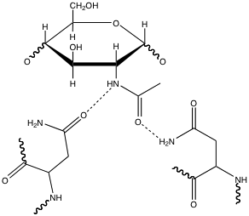

Shown are 2 different possible interactions.

Difficulty: 3 Topic: Glycoproteins

